 **RNS Institute of Technology, Bengaluru – 98**

(AICTE Approved, VTU Affiliated and NAAC 'A' Accredited)

**Department of Information Science and Engineering**

(Accredited by NBA for the Academic years 2018-19, 2019-20 and 2020-2021)

**Data structures Laboratory-18CSL38**

**Mini Project Evaluation**

|  |  |  |  |
| --- | --- | --- | --- |
| **Project Title** | Mini Project Medical Store Stock Management And Billing System | | |
| **USN** | 1RN19IS163 | 1RN19IS166 | 1RN19IS176 |
| **Name** | SURAJ R CHANNAGIRI | T VINAY | VINYAS K R |

**Abstract**

The purpose of Medical Store Stock Management And Billing System is to automate the manual system in some stores by the help of computerized equipments and full-fledged computer program, fulfilling their requirements, so that their data of stocks can be stored for a longer period with easy accessing and manipulation of the same. The required software and hardware are easily available and easy to work with.

Medical Store Stock Management And Billing System can assist the user to have a record of the medicines sold and also the information of the customers to which it is sold. Thus it will help organization in better utilization of resources such as providing discounts to the regular customers or promoting their store using the customer personal information such as phone number, email id etc. The organization can maintain computerized records without redundant entries. That means that one need not be distracted by information that is not relevant, while being able to reach the information.

Basically the project aims to provide good performance and better services for the Pharmacists.

**Introduction**

The "Medical Store Stock Management And Billing System" has been developed to overcome the problems prevailing in the practicing manual system. This project is supported to eliminate and in some cases reduce the hardships faced by the manual system. Moreover this project is designed for the particular need of the store to carry out operations in a smooth and effective manner.

The application is developed to reduce as much as possible the errors while entering the data. It also provides error message while entering invalid data. Only a Basic computer knowledge is needed for the user to use this system. Thus by this all it proves it is user-friendly Medical Store Stock Management And Billing System, as described above, can lead to error free, reliable and fast management system. It can assist the user to concentrate on their other activities rather to concentrate on the record keeping. And more developed version of such programs can you keep track of the profits ,expired medicines in the store and as well as the agencies supplying medicines.

**Description about the project work**

The Project mainly uses the Linked List Data Structure, Doubly Linked List in particular. Updating Stock creates a node in DLL and adding more stock keeps adding nodes to the DLL at the end. Deleting a stock is done by traversing to that position and deleting the particular node. Also, the Customer Info Management uses the same method to store information of the customer. Every Medicine has a unique barcode and every customer has a unique Id number. Billing System works using this unique numbers, firstly it asks the operator to give the id number of the customer and then asks for the number of medicines bought, later the operator has to give the barcode number of every medicine bought to add it to the bill and to calculate the total price to be collected from the customer. All the medicines bought are removed from the main stock and also printed in the bill to be given to the customer as well as in the complete record of medicines sold using file handling. And even the Date and Time at which the medicines were sold is also shown in the record. For any of these things to be done the admin login is required for which the username and password are set statically in the code so that there is some security features given to the client.

**Results**

Login using correct Username and Password

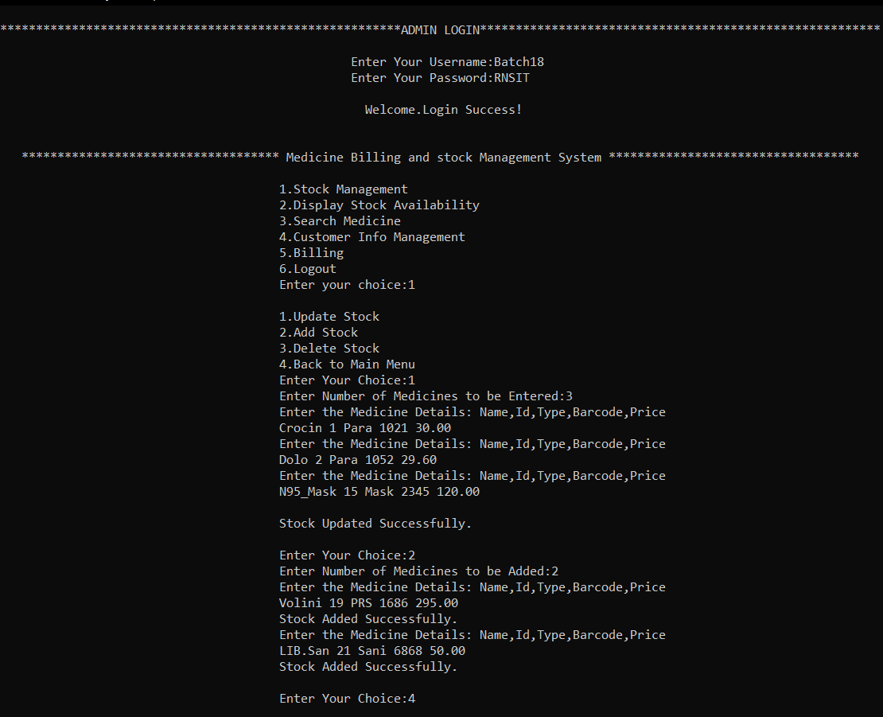

Login using correct Username and Password

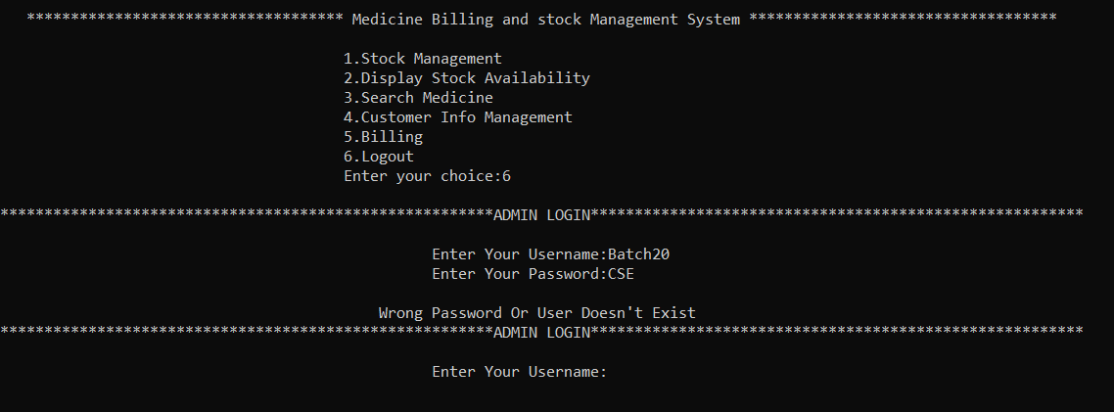



Update Stock and Add Stock

Displaying Stock

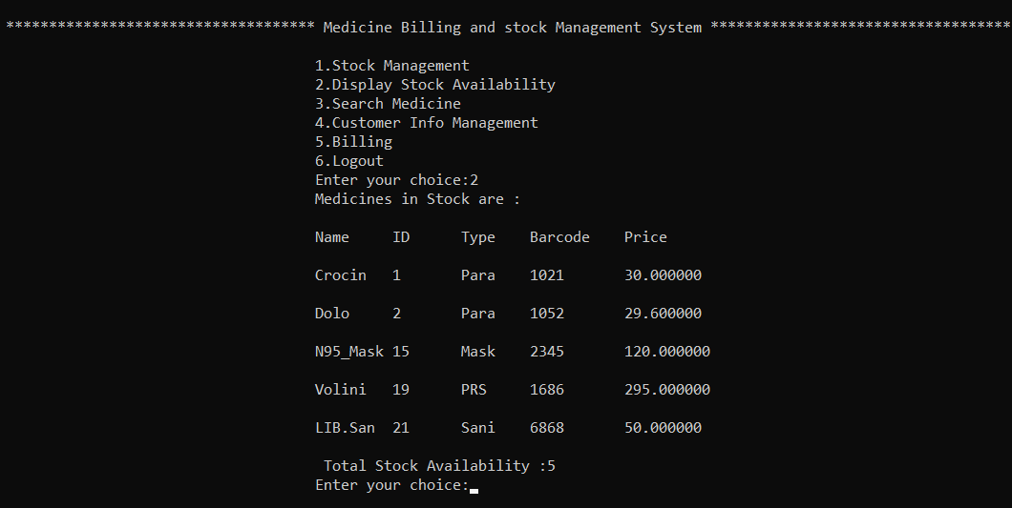

Deleting and Displaying Stock

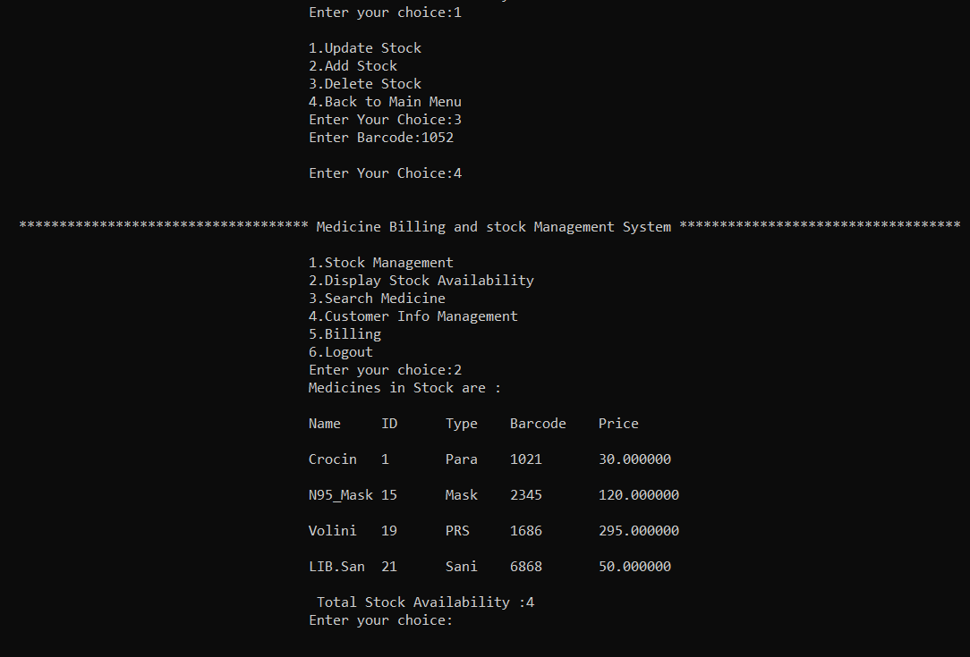

Searching Medicine Using ID

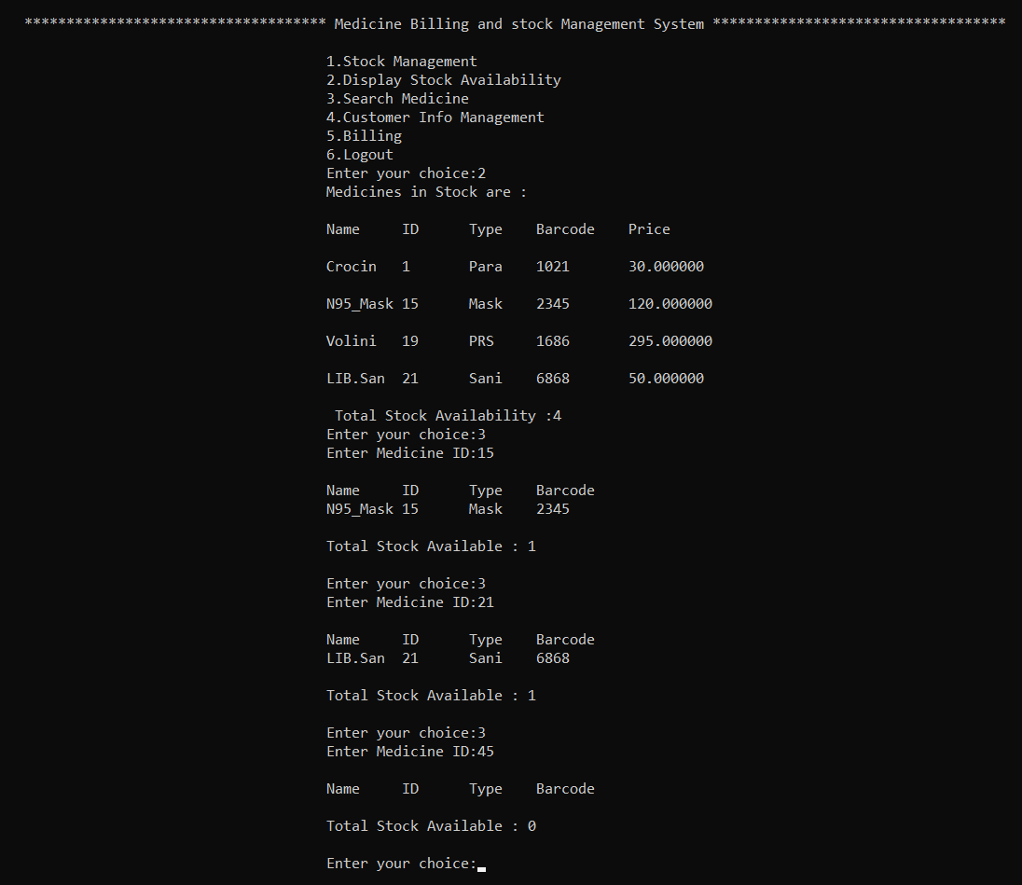

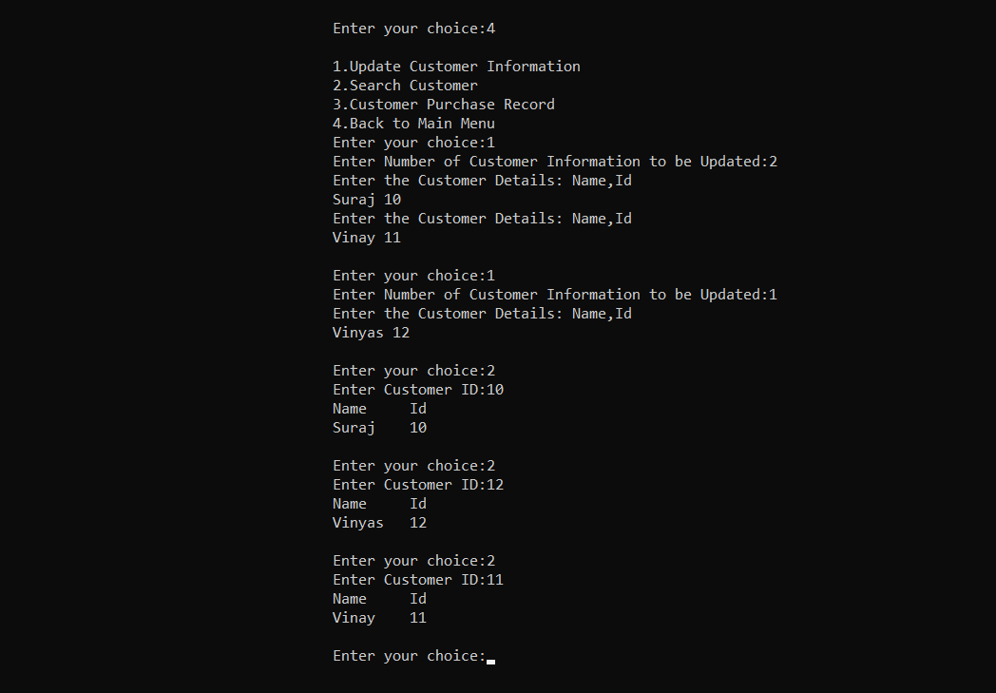

Customer Info Update and

Searching Customer using ID

Billing

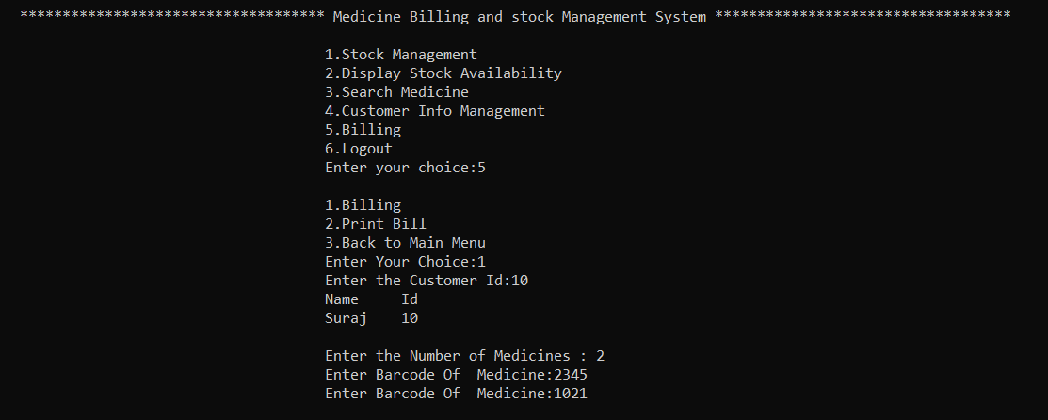

Print Bill

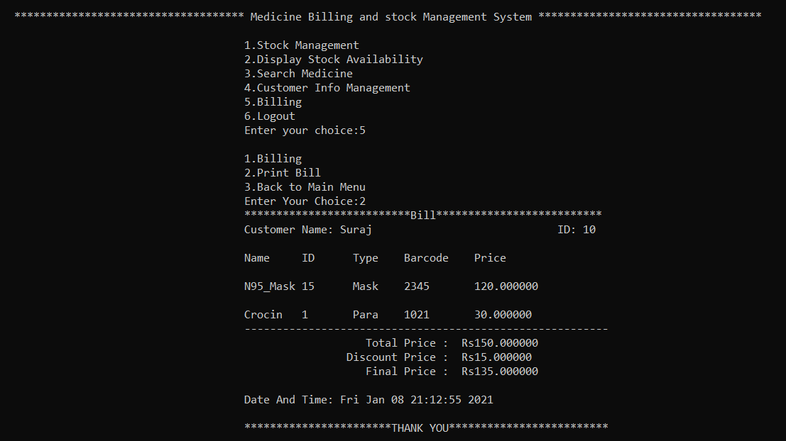

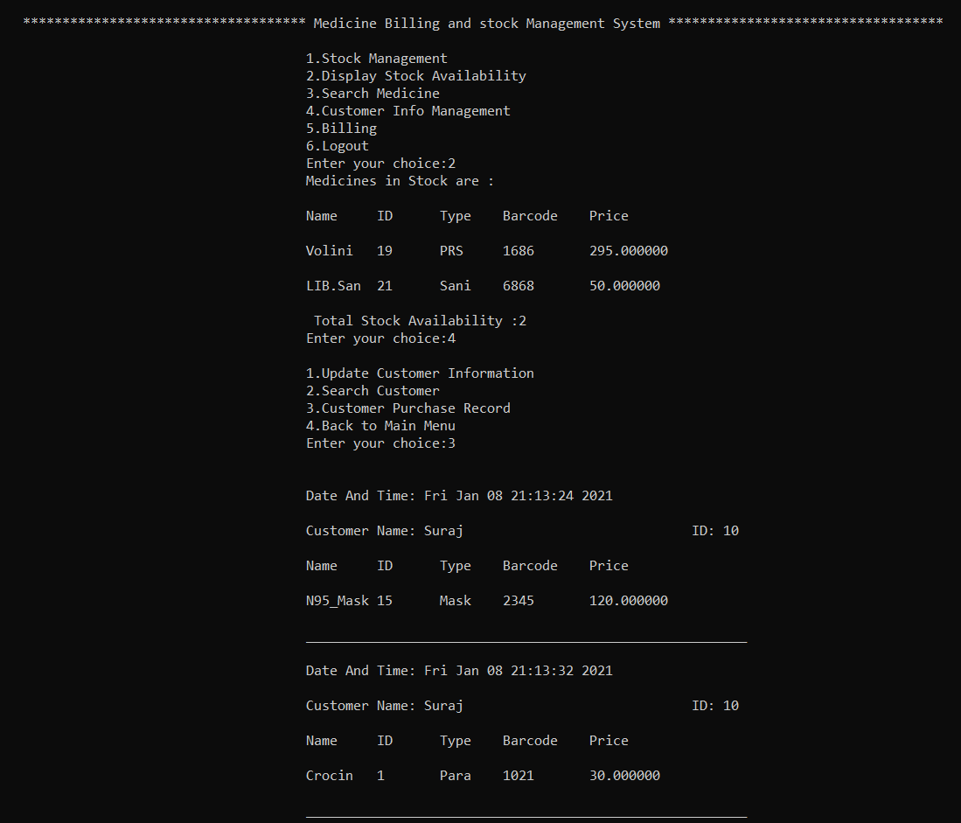

Stock Display and Purchase Record Display After Billing

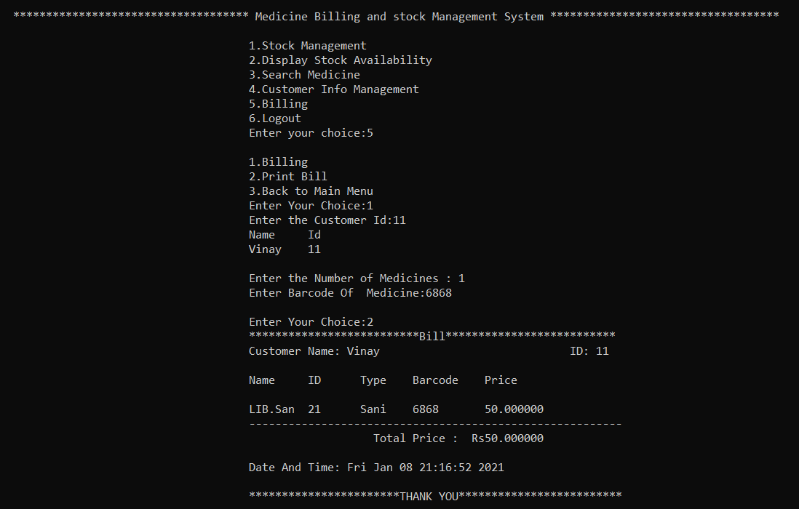

Billing and Display without Discount

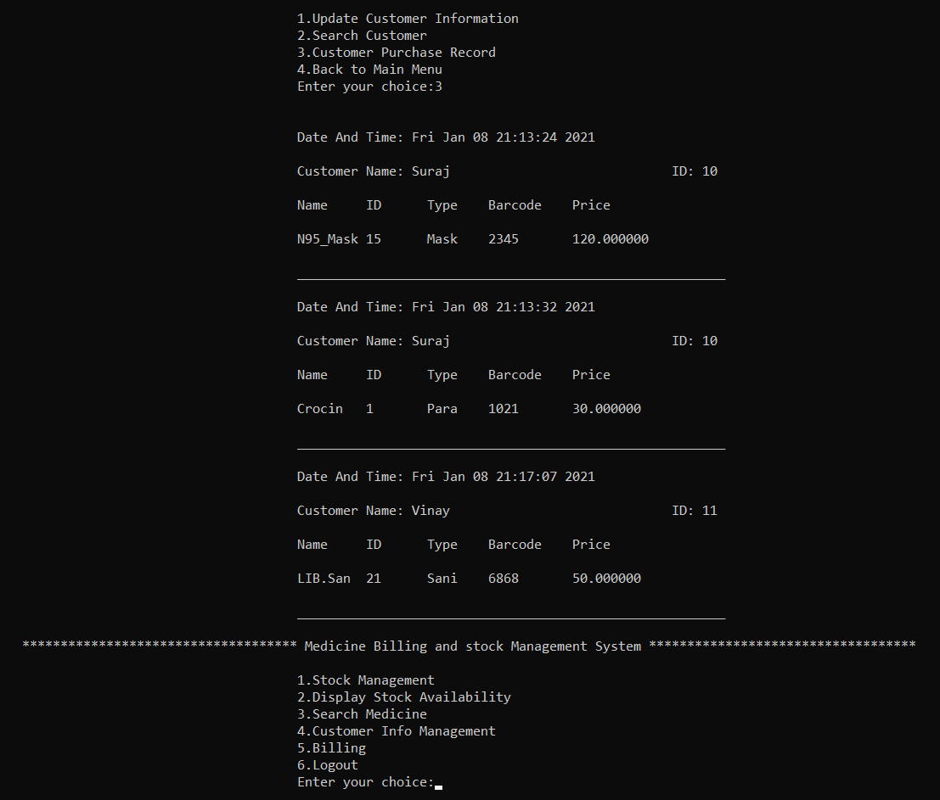

Purchase Record After 2nd Bill

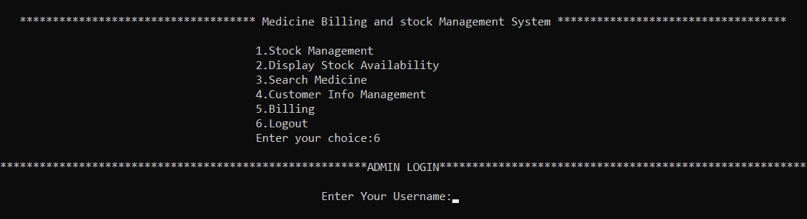

Logout

Bill With Discount

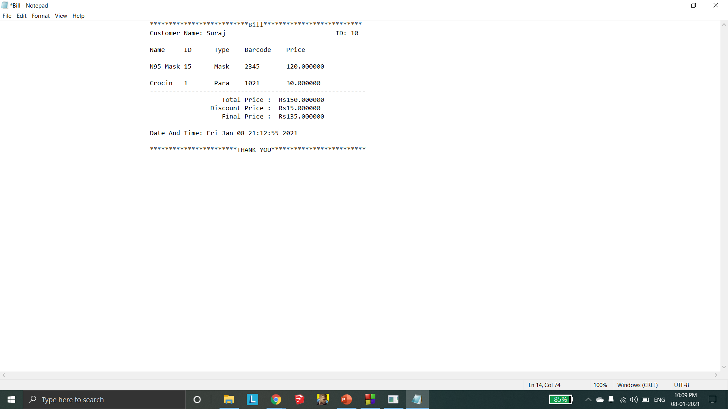

Bill Without Discount

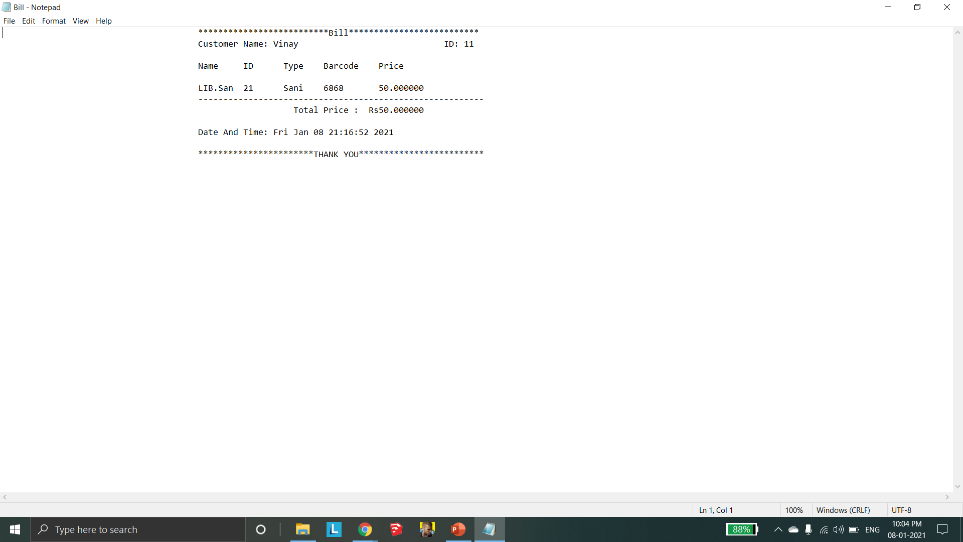

Customer Purchase Record

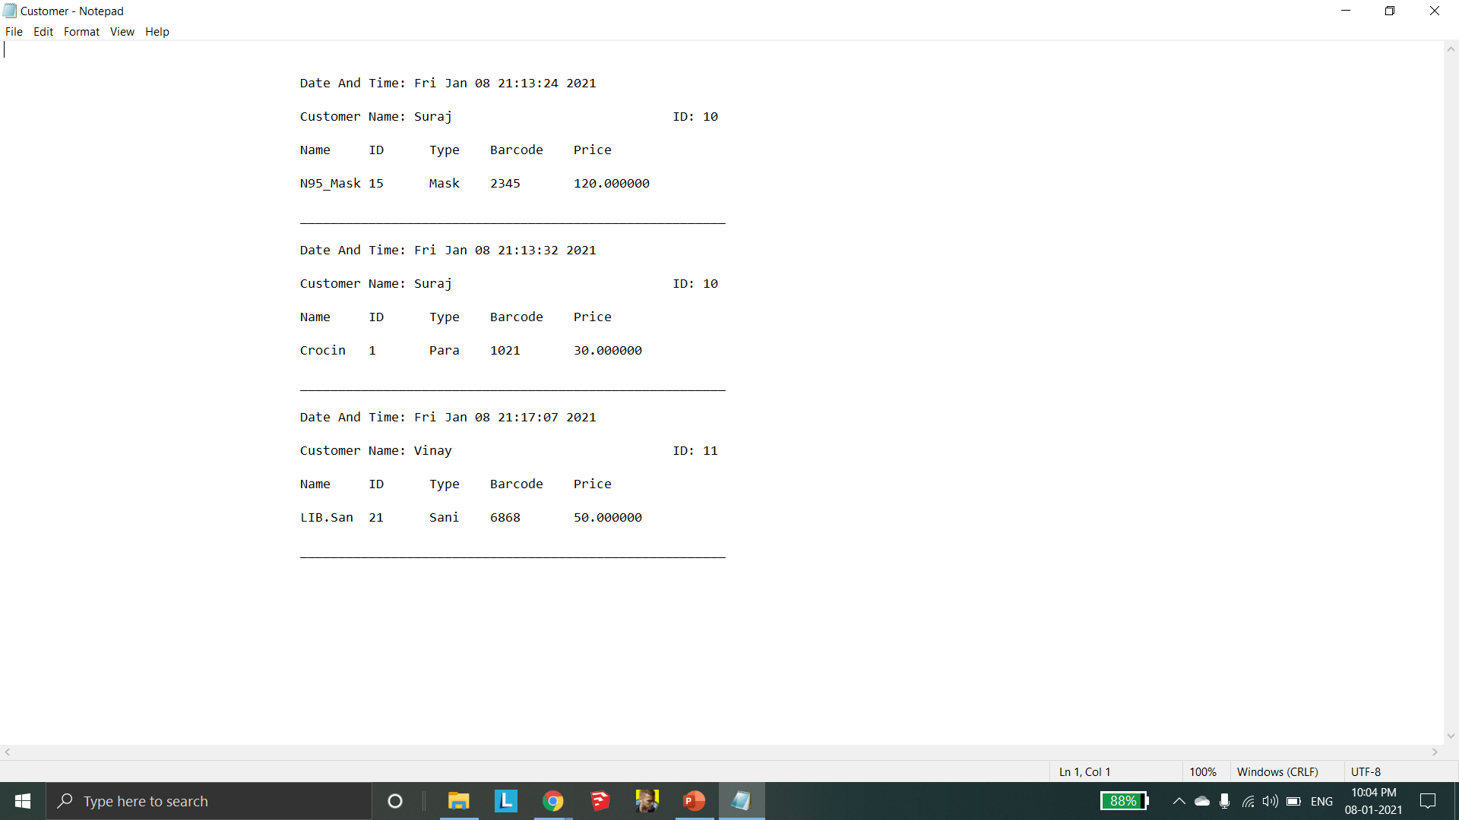

**Conclusion and Future Enhancements**

This project has made working in a medical store a much easy job. It maintains a log of every customer bill, generates a **bill automatically.** It provides every small to big details like customer details, purchase details, sell details, bill details, etc. The purpose of the project is to build an application program to reduce the manual work for managing the Sales, Medicine Stocks. **This project** is called the Medical Store Stock Management And Billing System.

The future enhancement that can be made in this project is linking the billing system of the same franchise so that the complete stock details can be maintained at higher levels also providing an access to the customers to check the medicines bought previously using their unique ID’s. Sending a softcopy of the bill to their Mobile/Email Id using their information stored previously.

**References**

* <https://www.geeksforgeeks.org/doubly-linked-list/>.
* <https://www.studytonight.com/c/>
* Ellis Horowitz and Sartaj Sahni, Fundamentals of Data Structures in C, 2nd Ed, Universities Press, 2014.
* Seymour Lipschutz, Data Structures Schaum's Outlines, Revised 1st Ed, McGraw Hill, 2014.